UNIVERSITY INSTITUTE OF COMPUTING

PROJECT REPORT
ON
ClearView: Insights at a Glance

Program Name: BCA
Subject Name/Code: Adwanced Web Development(23CAH-305)

Submitted by: Submitted to:
Name: Sanjana Chauhan Name: Mr. Abhineet Thakur
UID: 23BCA10150 Designation: AP
Section: BCA – 2 “B”

ClearView: Insights at a Glance

1. Title of the Project
ClearView: Insights at a Glance – A Student Management System

2. Objective of the Project
The objective of this project is to develop an interactive, web-based data visualization dashboard that provides users with comprehensive insights through dynamic charts, tables, and reports. The application aims to make complex data easier to understand and analyze using modern web technologies.
The system allows:
- Interactive data visualization using multiple chart types.
- Real-time data filtering and dynamic updates.
- Responsive design compatible with desktops, tablets, and mobile devices.
- User-friendly interface for exploring and exporting data.
- Secure authentication and role-based access control.

3. Software and Hardware Requirements

Software Requirements
- Operating System: Windows 10/11, macOS, or Linux
- Web Browser: Google Chrome 90+, Mozilla Firefox 85+, Microsoft Edge, or Safari 14+
- Development Tools: Visual Studio Code / PHPStorm
- Backend: PHP 8+ with Laravel Framework
- Database: MySQL
- Frontend: HTML5, CSS3, JavaScript, Bootstrap
- Version Control: Git & GitHub
- Testing Tools: Postman, Laravel Tinker

Hardware Requirements
- Processor: Intel i3 or higher (minimum)
- RAM: 4 GB (8 GB recommended)
- Storage: 10 GB free disk space
- Display: 1366×768 resolution or higher
- Internet: Required for external APIs and updates

4. Tools Used
Tool/Technology | Purpose
Visual Studio Code / PHPStorm | Code editor for PHP, HTML, and CSS
Laravel Framework | Backend framework for routing, MVC structure, and APIs
MySQL Database | Data storage and management
Bootstrap 5 | Responsive front-end design
Git & GitHub | Version control and collaboration
Postman | API testing and debugging
XAMPP / Laragon | Local development environment

5. Methodology

Step 1: Project Planning and Design
- Requirement analysis and feature documentation
- UI/UX design using Figma and wireframes
- Database schema and table relationships design
- Selection of technology stack (Laravel + MySQL )
Step 2: Development Approach
- Frontend: Developed with HTML, CSS, Bootstrap, and JavaScript for interactivity.
- Backend: Built using Laravel (MVC structure), managing routes, models, and controllers.
- Database Integration: Connected using Laravel’s Eloquent ORM for efficient data management.

Step 3: Implementation Phases
- Setup Laravel project and environment.
- Design database schema and migrations.
- Create models, controllers, and routes.
- Implement data retrieval and filtering.
- Design responsive user interface with Bootstrap.
- Add export features (PDF, CSV).
- Testing, debugging, and optimization.

6. Core Features and Implementation

Key Features:
- Multiple Chart Types: Bar, Line, Pie, and Doughnut charts.
- Real-Time Data Updates: Charts refresh automatically when new data is added.
- Interactive Filters: Filter data by date, category, or custom criteria.
- Responsive Dashboard: Layout adapts seamlessly to all devices.
- Data Export: Export reports and visualizations in PDF or CSV format.
- User Authentication: Secure login and role-based access using Laravel Auth.
- Dashboard Summary Cards: Display quick statistics and KPIs.

7. Development and Deployment Steps

Step 1: Environment Setup
- Install Laravel using Composer.
- Configure .env file for database connection.
- Run migrations and seed data.
- Install necessary dependencies (npm, composer).
Step 2: Development Process
- Backend API routes created using Laravel’s routing system.
- Controllers handle business logic and database queries.
- Views built using Blade templates for dynamic rendering.
- Chart.js integrated with data endpoints via AJAX.
- Implemented responsive layout with Bootstrap grid system.

Step 3: Testing and Deployment
- Tested endpoints with Postman.
- Performed cross-browser and mobile testing.
- Optimized SQL queries and caching.
- Created production build and deployed using cPanel or Laravel Forge.

8. Sample Output
The ClearView Dashboard Includes:
- Header: Title bar, user profile, and logout option.
- Sidebar: Navigation menu for charts, reports, and filters.
- Main Panel: Displays dynamic charts and tables.
- Summary Cards: Quick overview of key data metrics
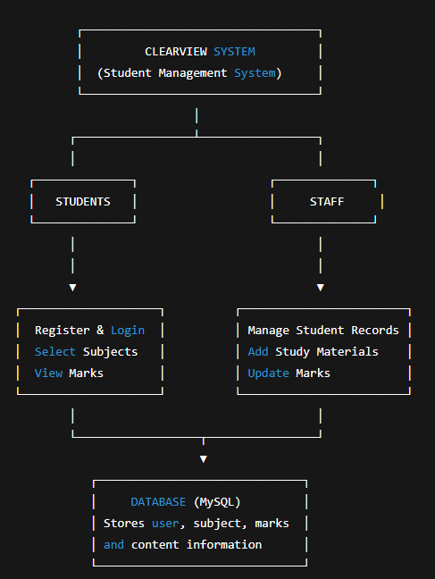

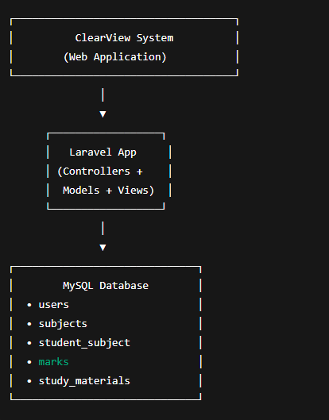

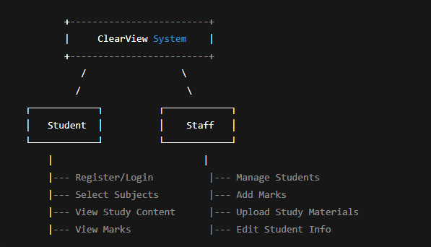

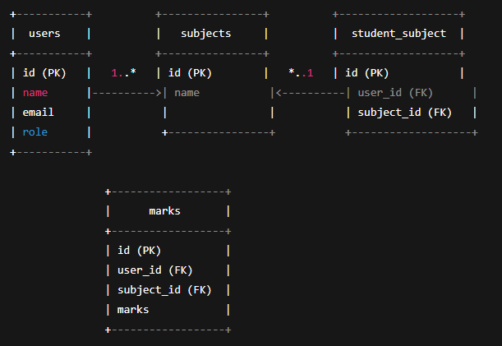

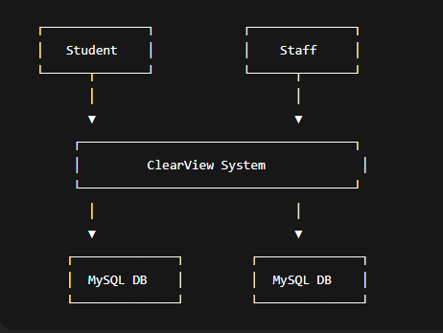

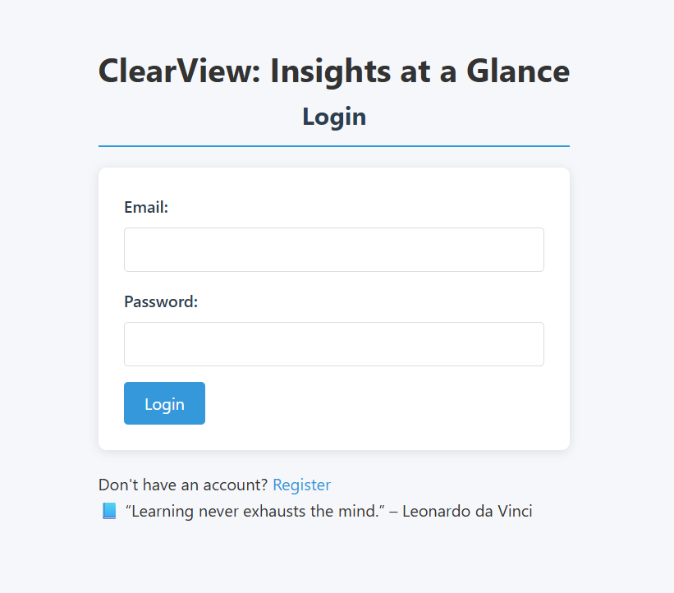
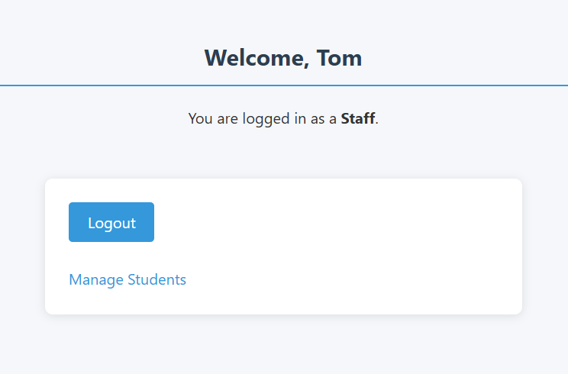.
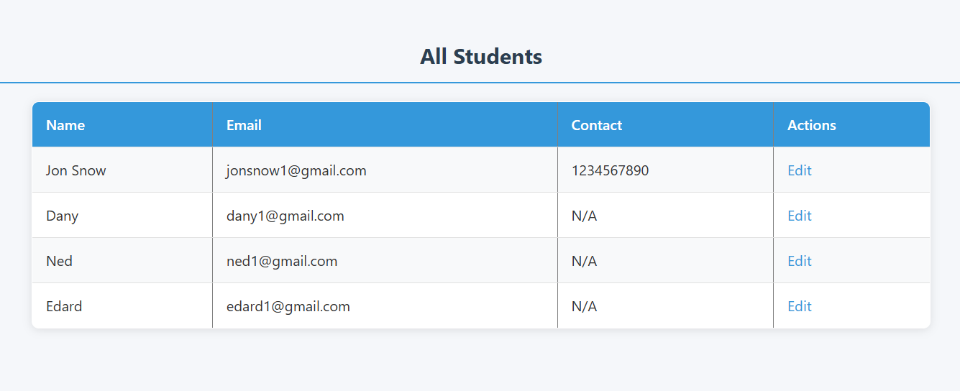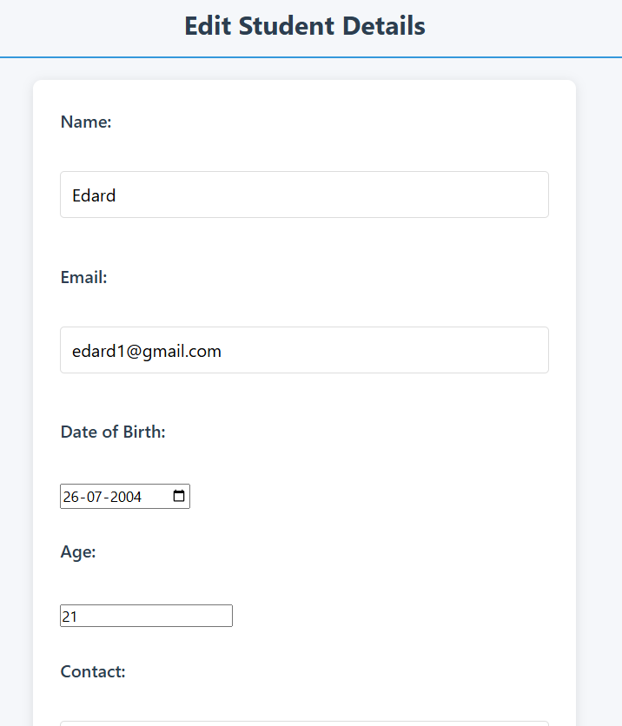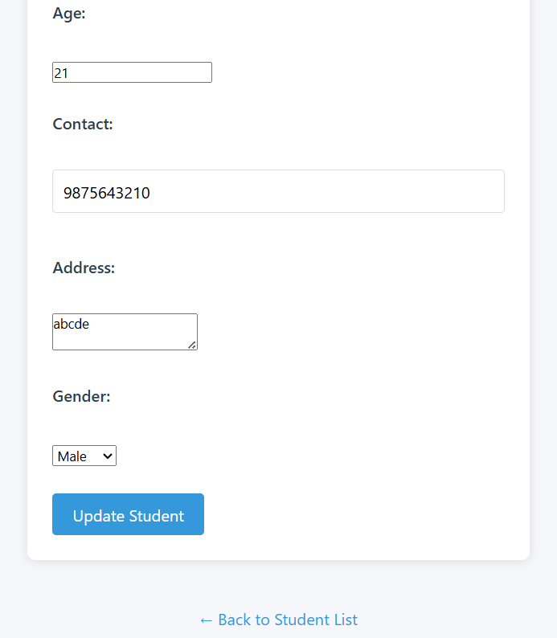
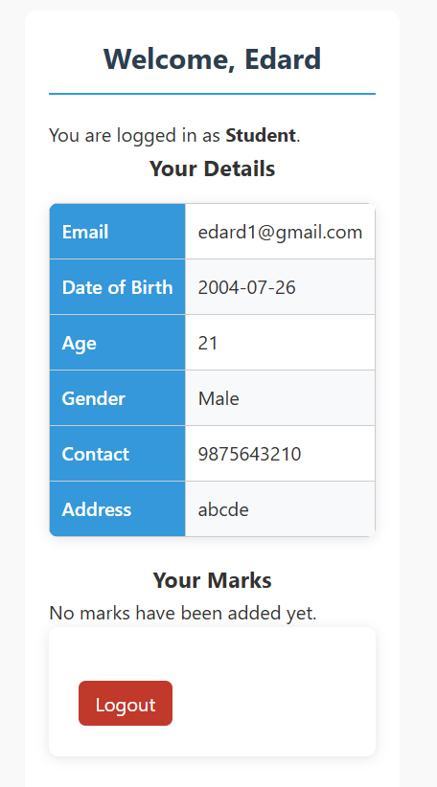

9. Result
The project successfully achieved its objectives by creating a responsive and interactive data visualization dashboard using Laravel and Chart.js.
It offers:
- Smooth and responsive interface.
- Accurate data representation through charts and graphs.
- Real-time filtering and analysis.
- Secure and efficient backend operations.
- Compatibility across major browsers and devices.

10. Conclusion
ClearView: Insights at a Glance demonstrates the potential of Laravel and modern web technologies in developing professional data visualization dashboards.
The project provides a solid foundation for analytical tools used in business intelligence, allowing users to visualize complex datasets effectively.

11. Future Enhancements
- Machine Learning Integration: Predictive analytics and data trend forecasting.
- Custom Visualization Builder: Drag-and-drop chart creation.
- Collaboration Tools: Multi-user access with shared dashboards.
- Mobile App: Native mobile version using Flutter or React Native.
- AI Chat Integration: Query data using natural language.
- API Integrations: Integration with third-party services like Google Analytics or Power BI.

12. References
- Laravel Official Documentation (https://laravel.com/docs)
- MySQL Reference Manual (https://dev.mysql.com/doc/)
- Bootstrap Documentation (https://getbootstrap.com/docs/)
- PHP Manual (https://www.php.net/manual/)
- Web Accessibility Guidelines (WCAG)
- Responsive Web Design Principles (MDN)

